The heatmap issue mentioned on the tracker has not been done. They’ve asked to change the heatmap interval editor into hourly heatmap and below 0-24 into 0-24hrs

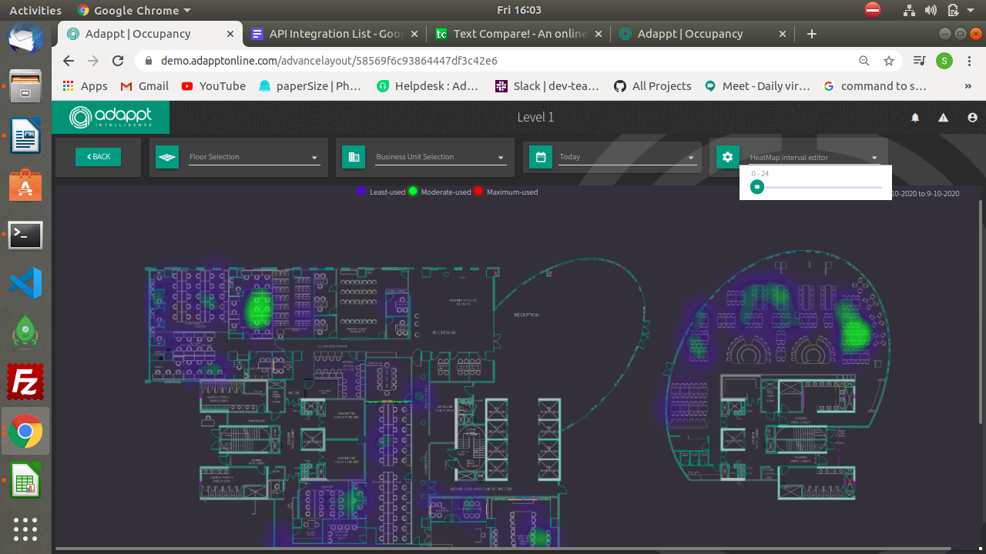

The order of the floors should be in ascending order(in the occupancy chart below the graph)

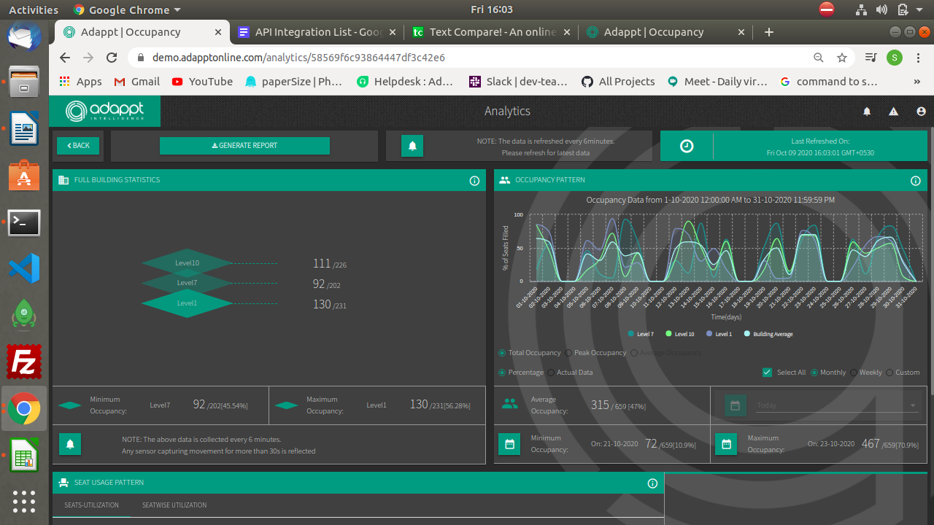

I cannot book the room from 11pm to 11:30pm, though i dont have meeting at that time. Still its

thowing an error like “ you’ve another at this time”

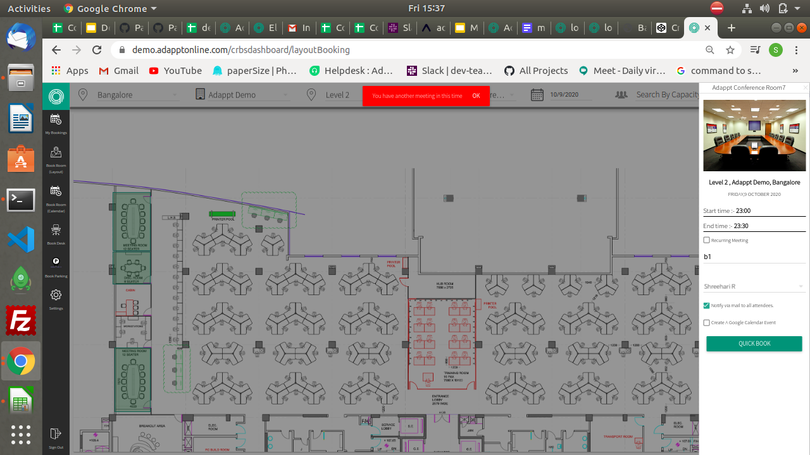

The room booked at 6pm to 7pm is not displaying in the daily calender though its friday

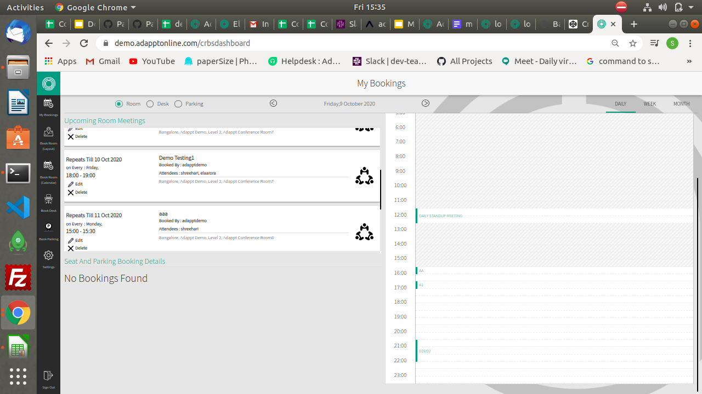

Room name “a1” and room name “edio1” were booked at same timings and room “b2” and “b3”

at the same timings. It dint throw any error while booking and also while ed

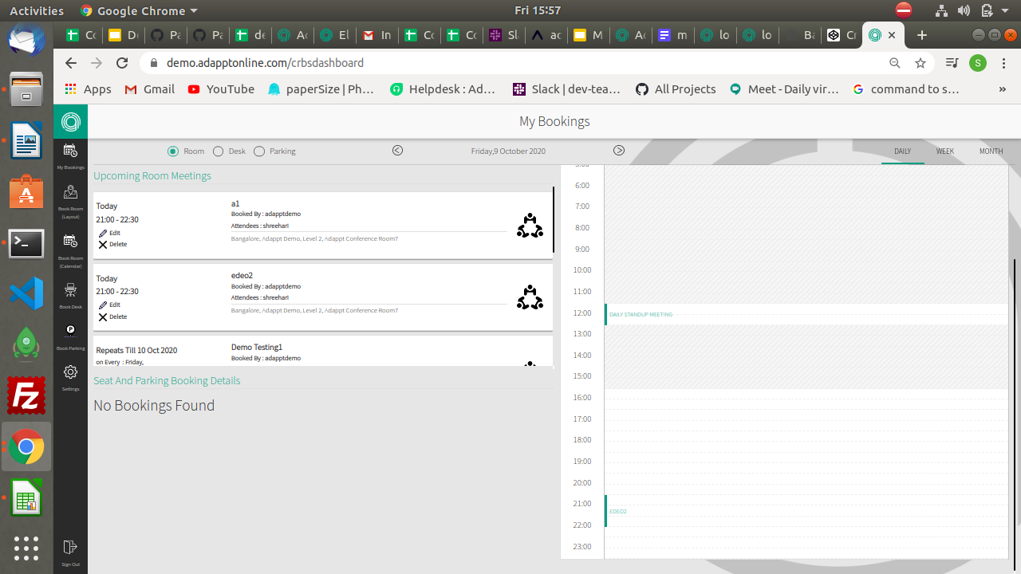

While selecting time, pull-down menu shows the 24hr format and the time displays in the 12hr format.

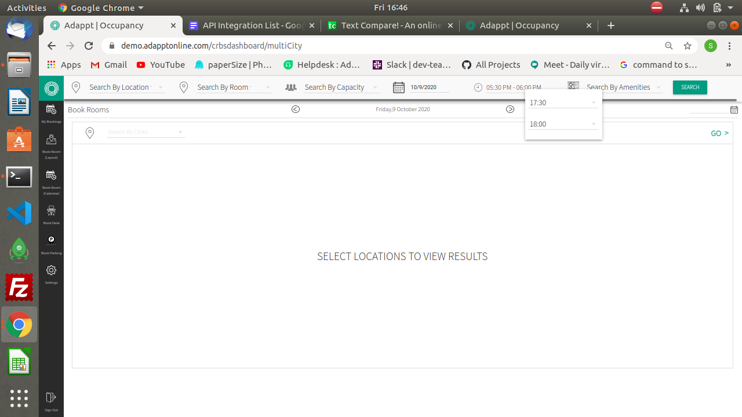

Here we can book the room(calendar) which has already been booked(in layout) see room c1 and d1 booked at same time.

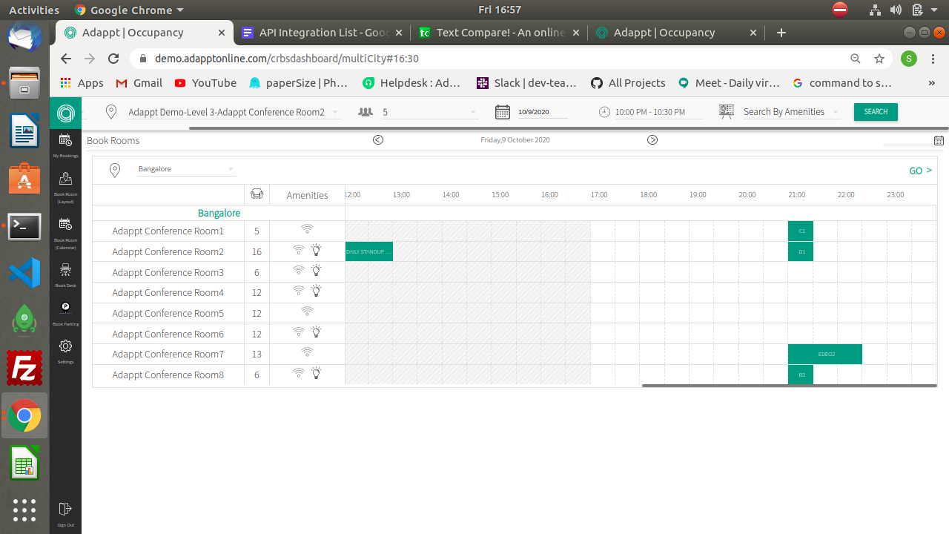

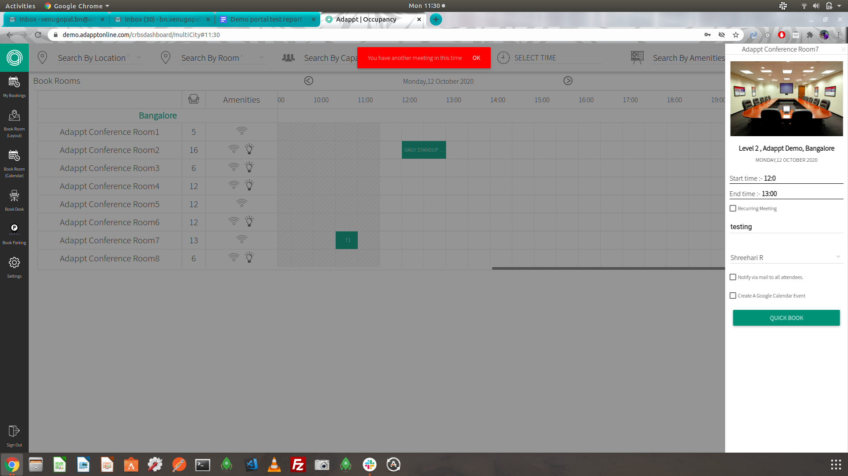

Again some numbers are arising in the middle of the bar graph

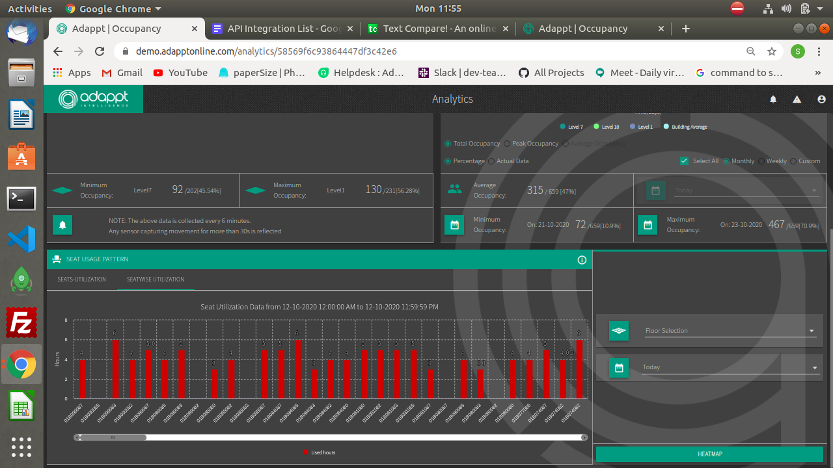

Is it possible to update the booked desk, which is currently on use?

Here the desk are still visible on the my bookings, where the booked time is already got over

